Software Operation Manual

Autodiscipline

Version 1.1 | 19 July 2022

Table of Contents

1 Introduction 3

1.1 What is Autodiscipline? 3

1.2 Operating Environment 3

2 Manual Operations 6

2.1 Operating the To-Do Board 6

2.2 Operating Journal Entries 6

2.3 Operating Habit Trackers 6

# Introduction

## What is Autodiscipline?

Autodiscipline is a flexible and fast system that facilitates to remove the disorganisation in your life, one that is easy enough to use for it to become a habit that sticks to your everyday routine. The application allows you to track the past, organises the present and plans for the future, i.e. keep track of the things you’ve done, the things that needs to be done, and the things that you aspire to do.

The Autodiscipline application comprises the following functionalities:

* Task/To-Do board
* Journal entry system
* Timer-style habit trackers

## Operating Environment

Supported OS:

* Windows 7 (32/64-bit, Home Premium and higher) SP1+
* Windows 8 (32/64-bit, Professional and higher)
* Windows 10 and higher

CPU: 11th Gen Intel® Core™ i5-1135G7 (8 MB cache, 4 cores, 8 threads, up to 4.20 GHz Turbo) or greater

Display resolution: 800 x 600 pixels or greater

Web browser: Chrome version 103 or higher

# Manual Operations

This chapter contains the following sections:

* Operating the To-Do Board
* Operating Journal Entries
* Operating Habit Trackers

On start, the application will direct you to the Home page:

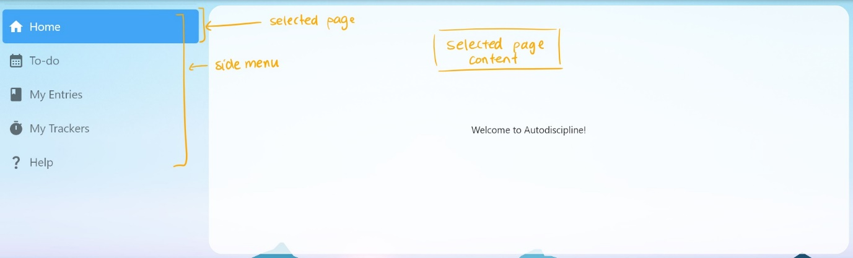

The side menu provides access to all the features comprised within the application.

The tab highlighted in blue indicates the active page, displayed in the white region on the right side of the side menu.

Click on any of the tabs to change the page and access other functionalities.

## Operating the To-Do Board

The To-Do board can be accessed by clicking on the second tab on the side menu.

Click on the “+” button at the bottom-right corner to create a new task.

A preview card shown on the board indicates a saved task, with the name and the date that have been assigned to the task. Click on an existing preview card displayed on the board (if any) to view and edit the task.

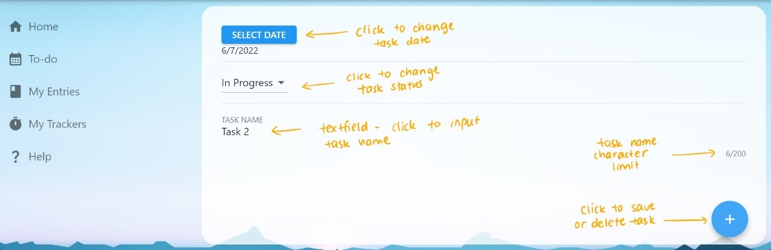

By selecting an existing task or clicking on the “+” on the To-Do page, the application will direct you to this page.

The details of a task can be customised here. Click on the “SELECT DATE” button to operate the date picker to change the date that will be assigned to the task, which will be displayed below the button.

The drop-down selector below the “SELECT DATE” button indicates the selected status of the task. Click on the selector to change the status to “To-Do”, “In Progress”, or “Done”.

Click on the region below “TASK NAME” to change the task name, which has a character limit of 200 and only accepts alphanumeric inputs.

Click on the “+” button at the bottom-right corner to select to save or delete this task. The program will need to be refreshed after saving or deleting the task to update the To-Do board.

## Operating Journal Entries

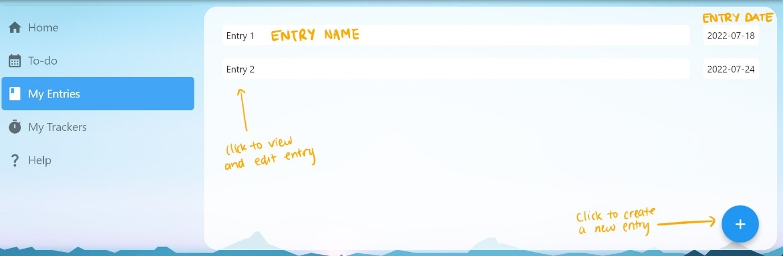

The journal-entry functionality can be accessed through the “My Entries” page, which can be viewed by clicking on the third tab on the side menu.

This page displays all the entries that have been saved, with the entry name in the left column and the entry date in the right column. Click on the “+” button on the bottom-right corner to create a new entry.

Click on any entry name tile on the left to view and edit the existing entry.

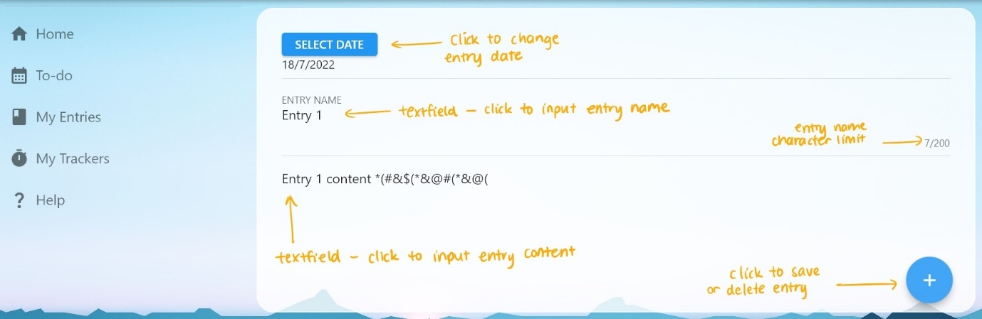

By selecting an existing entry or clicking to create a new entry, the application will direct you to this page.

The details of an entry can be customised here. Click on the “SELECT DATE” button to operate the date picker to change the date that will be assigned to the entry, which will be displayed below the button.

Click on the region below “TASK NAME” to change the task name, which has a character limit of 200 and only accepts alphanumeric inputs.

Click on lowest region to edit the entry details.

Click on the “+” button at the bottom-right corner to select to save or delete this entry.

## Operating Habit Trackers

The habit tracking functionality can be accessed through the “My Trackers” page, which can be viewed by clicking on the fourth tab on the side menu.

The two default trackers provided by the program are made for tracking exercise and study with a timer.

The goal time for the habit can be set by clicking on the settings icon on the far-right side of the habit tile.

Click the button inside the progress circle to start or stop the tracker timer.

Click the empty hourglass icon to reset the timer.

The label below the tracker name indicates the habit progress.